Geometry
Chapter 2

Question | #1 | #2 | #3 | #4 | #5 | #6 | #7 | #8 | #9 | #10 | #11 | Total
Possible Points | 10 | 5 | 15 | 5 | 5 | 5 | 5 | 10 | 10 | 15 | 15 | 100
Points
Earned

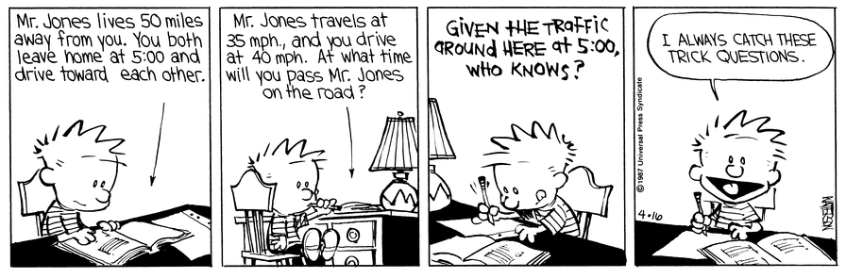

1. Describe the pattern and say what the next two numbers in the sequence are.

4, 6, 9, 13, 18, . . .

2. Rewrite the conditional statement in if-then form.

There are 12 eggs if the carton is full.

If-then form: If ________________________ then __________________________.

3. Match the converse, inverse, and contrapositive of the following statements and state whether or not each statement is True or False.

If I play the flute, then I’m a musician.

If I’m a musician then I play the flute
Converse

Inverse

Contrapositive

If I’m not a musician, then I don’t play the flute.

If I don’t play the flute, then I’m not a musician.

If Poe wants to leave learning lab, then he needs to write a pass.

If Poe doesn’t need to write a pass, then he does not want
to leave learning lab.
Converse

Inverse

Contrapositive

If Poe does not want to leave learning lab, then he does
not need to write a pass.

If Poe needs to write a pass, then he wants to leave
learning lab.

4. Rewrite the biconditional statement as a conditional statement and its converse.

Two lines are perpendicular if and only if they intersect to form right angles

Conditional statement:

Converse:

5. Fill in the blank of the following statement.

Completing and solving proofs uses ________________ reasoning, through facts and laws of logic.

6. For the following statements, draw a picture to illustrate each postulate.

- If two points lie in a plane, then the line containing them lies in the plane.

- If two lines intersect, then their intersection is exactly one point.

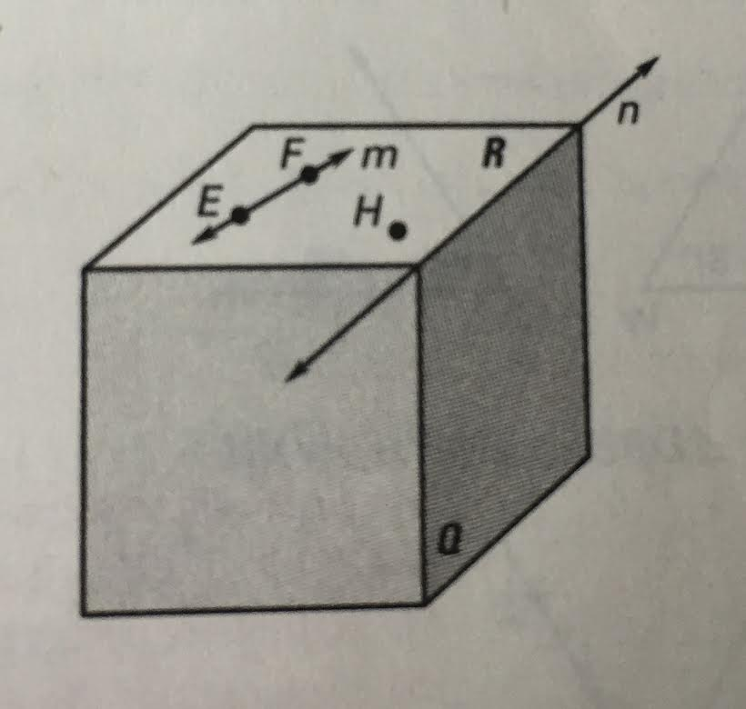
7. Use the diagram to decide whether the
statement is true of false.

- Points E, F, and H lie in plane R.

True or False

- The intersection of planes Q and R form line n.
True or False

- Points E and F lie in the plane R, thus line m lies entirely in plane R.

True or False

8. Solve the following equations and give a reason for each step. (hint: The tables are the perfect size for each problem)

a.
8x – 5 = -2x -15 | Given
x = -1

b.
5(2x – 1) = 9x + 2 | Given

9. Solve for x and y, and state what each angle is equal to.

$$(17y-9)°$$

$$(5x+1)°$$
$$4y°$$

$$(21x-3)°$$

10. Complete the following proofs by a two column proof .

a. $If ∠1≅∠2, then ∠3 ≅∠4$.

1

41
2
31

Reasons
Statements

11. Complete the following proofs by a two column proof AND a written proof.

Given: AL = SK
L
S
K
A
Prove: AS = LK

Reasons
Statements

